

**NSSA Lab - 03**

Suhaila Alfalasi

Rania Kanaan

RIT Dubai

Professor [Muhammad Haseeb Jalalzai](mailto:mhjcad@rit.edu)

March 31, 2024

**Setting the ip manually**

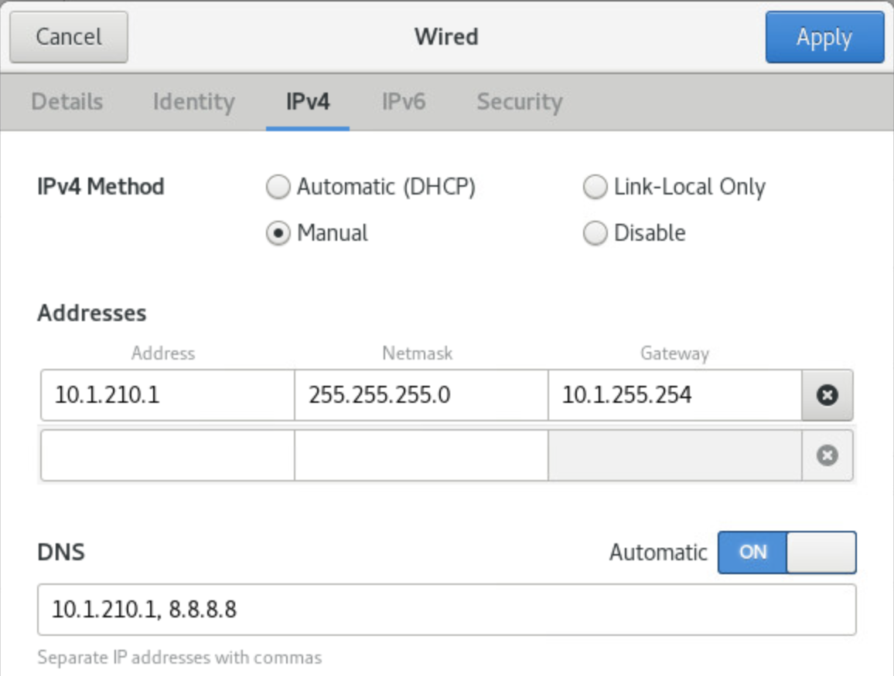

**Changing the Centos hostname**

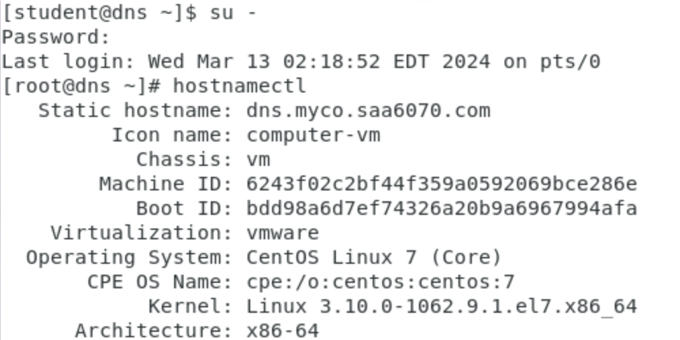

**Updating**

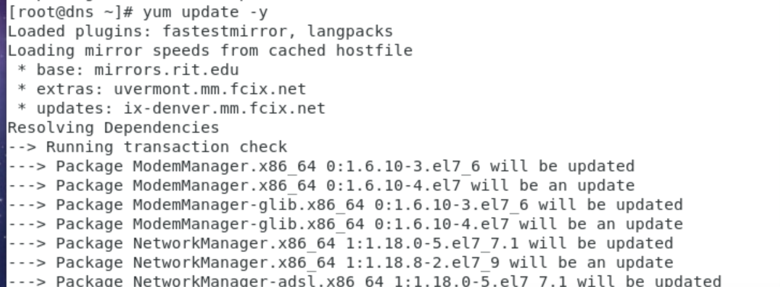

**Editted the /etc/selinux/config file to permissive**

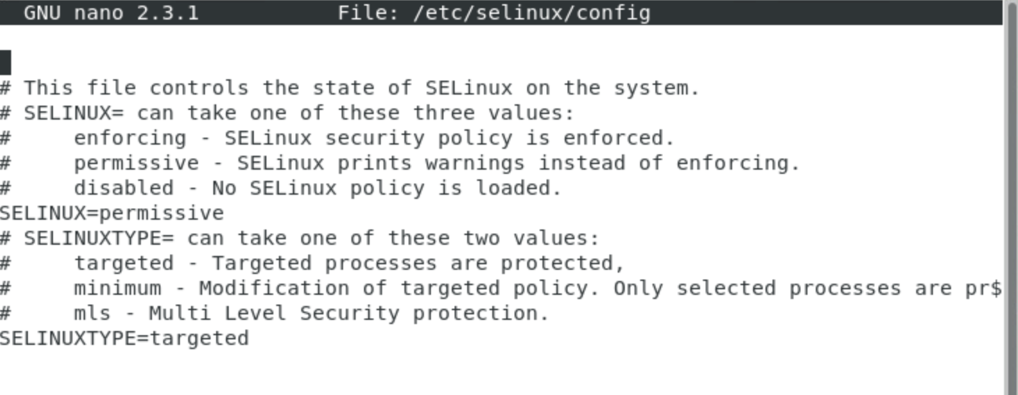

**Installing the bind**

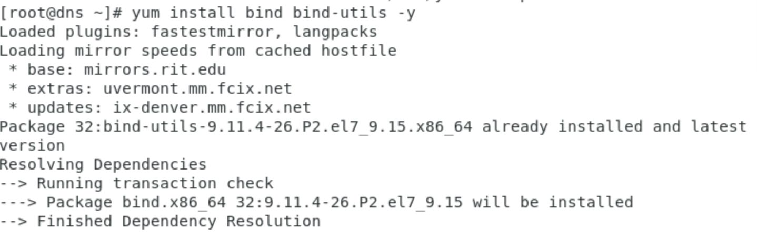

**List services DNS is listed**

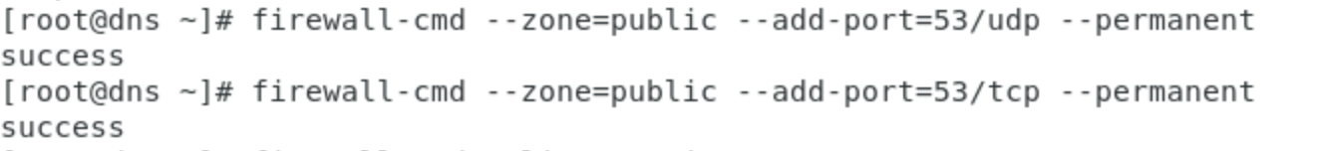

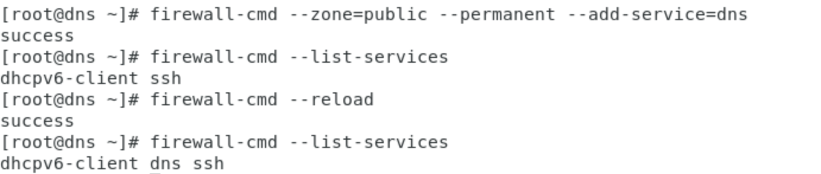

**Configuration of myco.saa6070.com.dns**

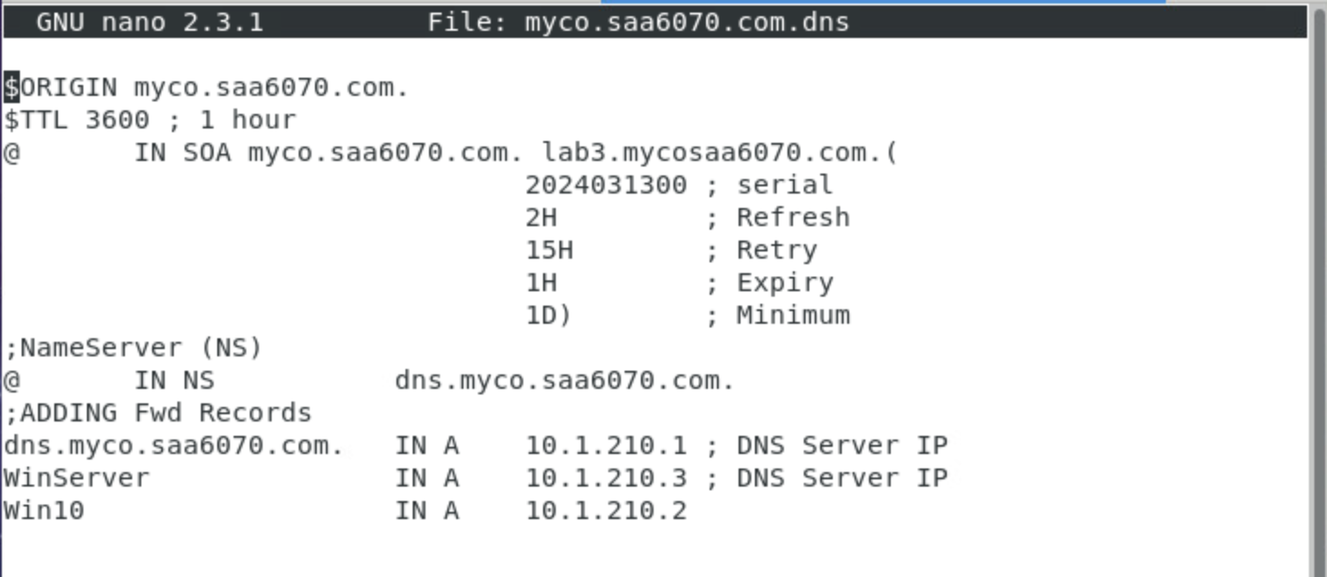

**Editing the /etc/hosts file**

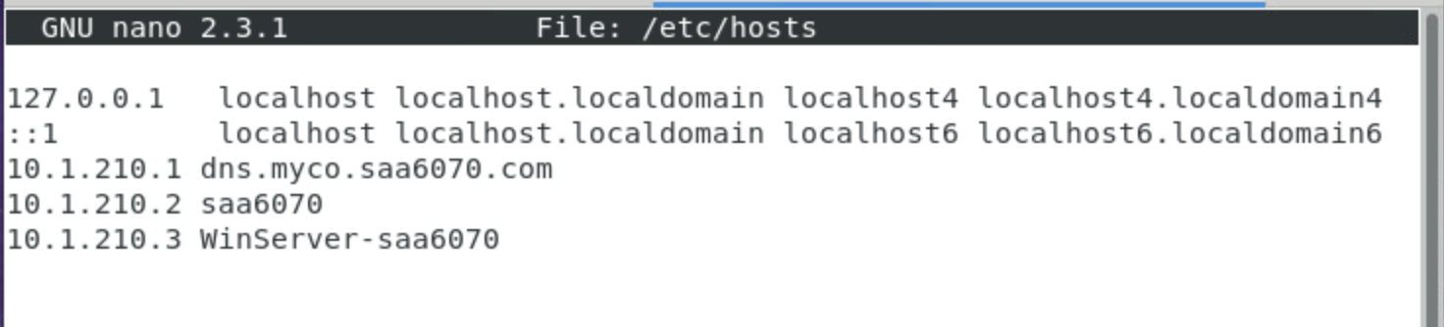

**Checking**

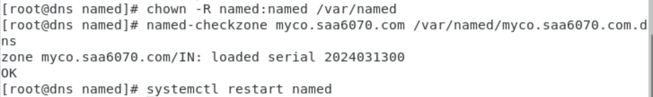

**Rev.10.1.210 configuration file**

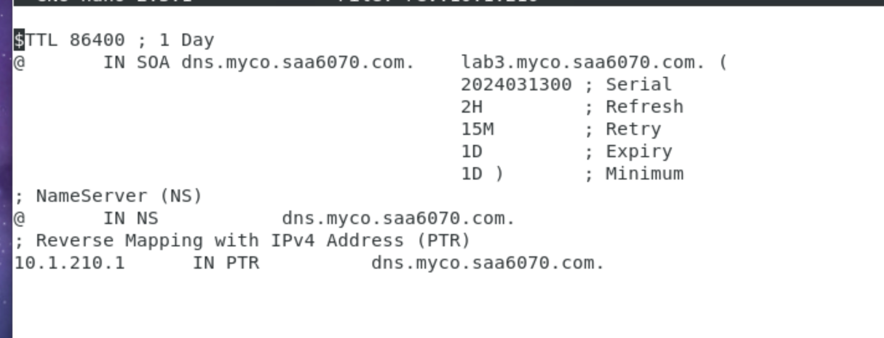

**Checking**

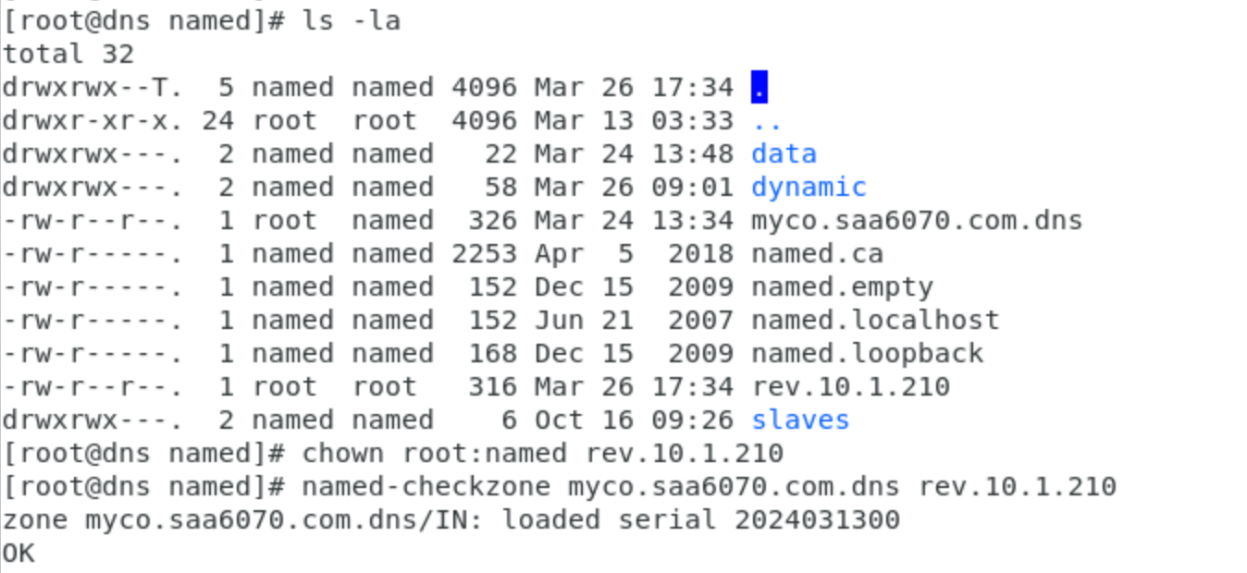



**Edited the /etc/named.conf**

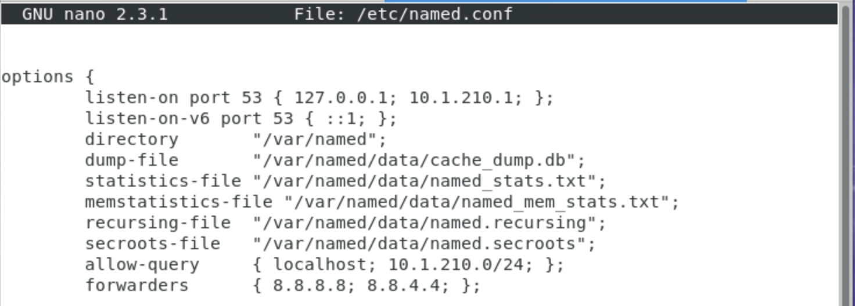

**Edited the /etc/named.rfc1912.zones**

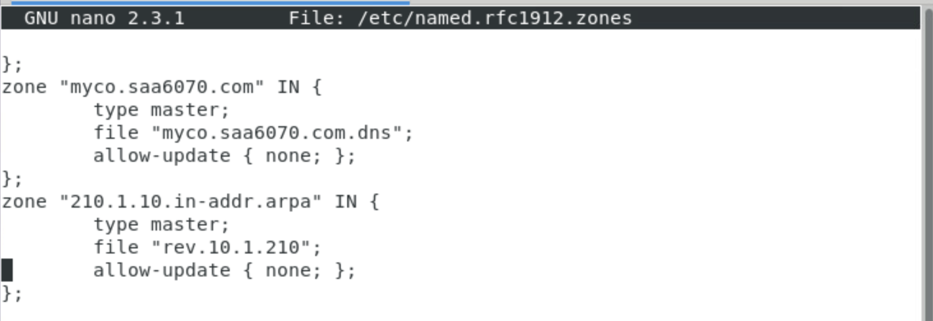

**The status is Active**

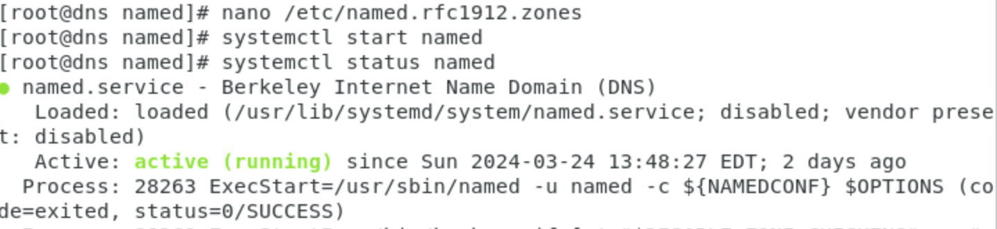

**Edited the /etc/resolv.conf File**

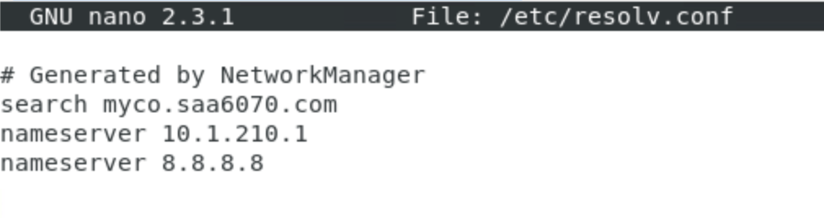

**Used the dig A dns.myco.saa6070.com command**

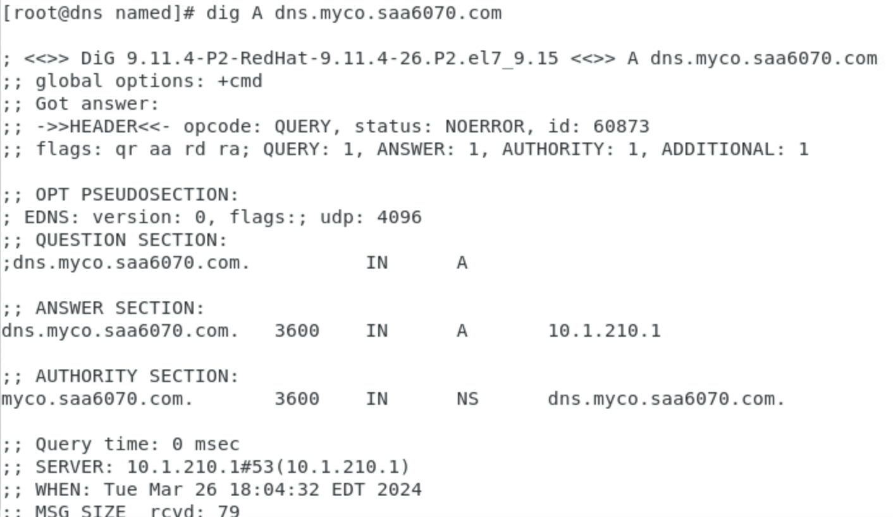

**Using the command dig +trace dns.myco.saa6070.com**

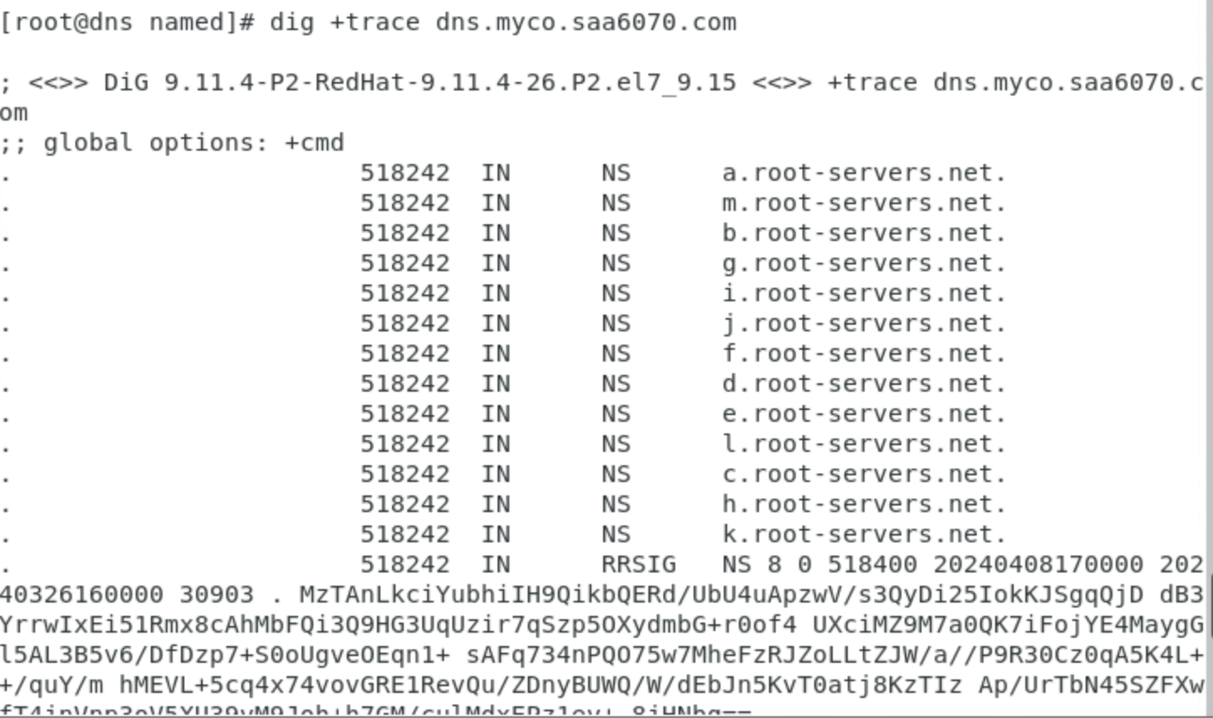

**Using ‘tail -f /var/log/messages’ command to see the system error messages in real-time while starting the named service**

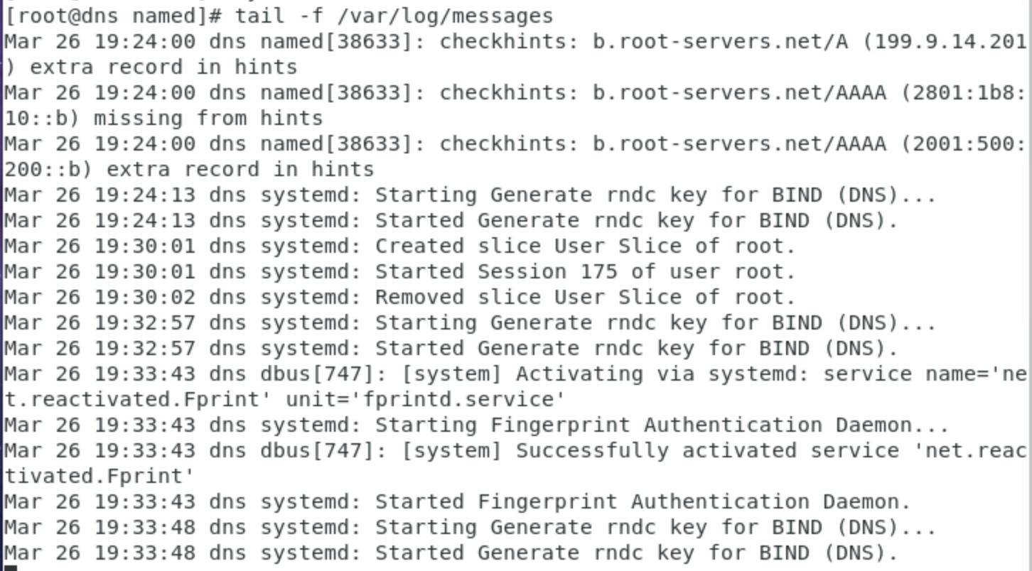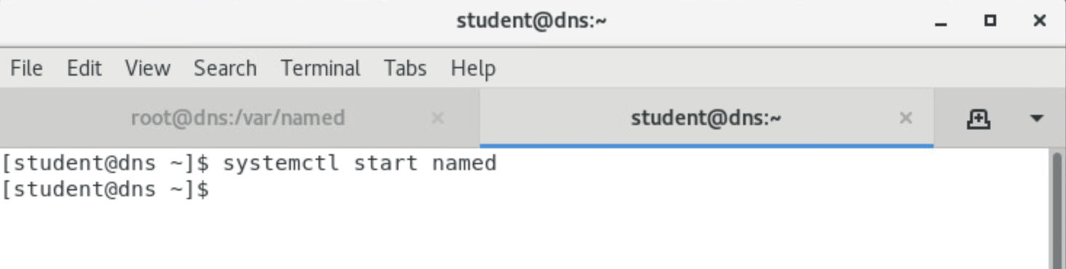

**Using the rndc Command**

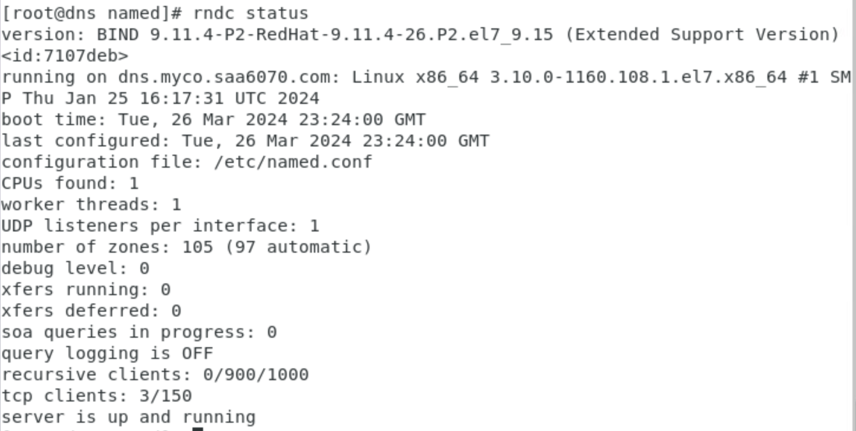

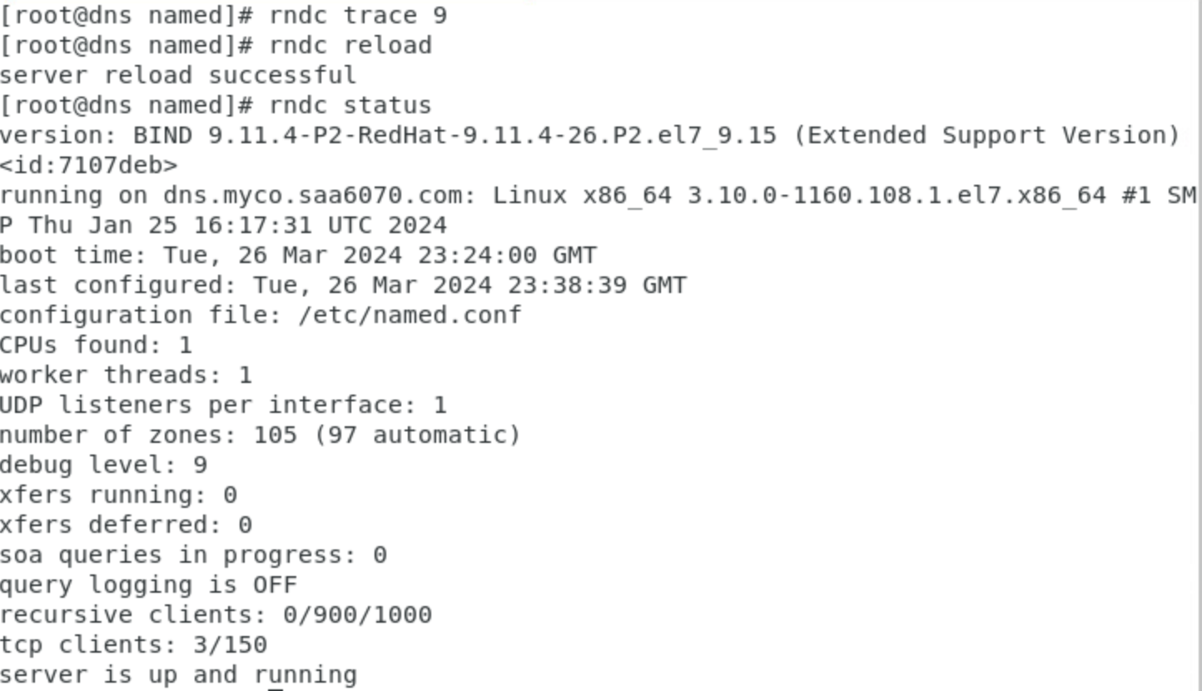

**The usage of the nslookup**

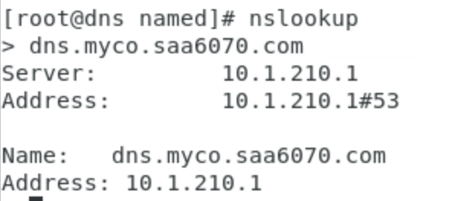

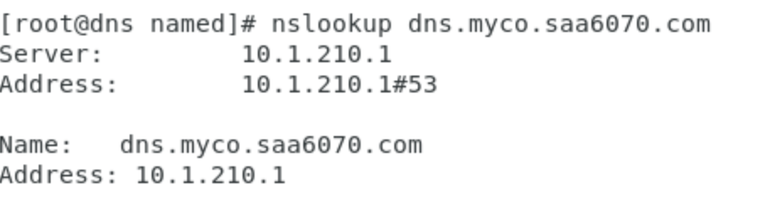

**Perform a DNS query for the authoritative name servers of the domain**

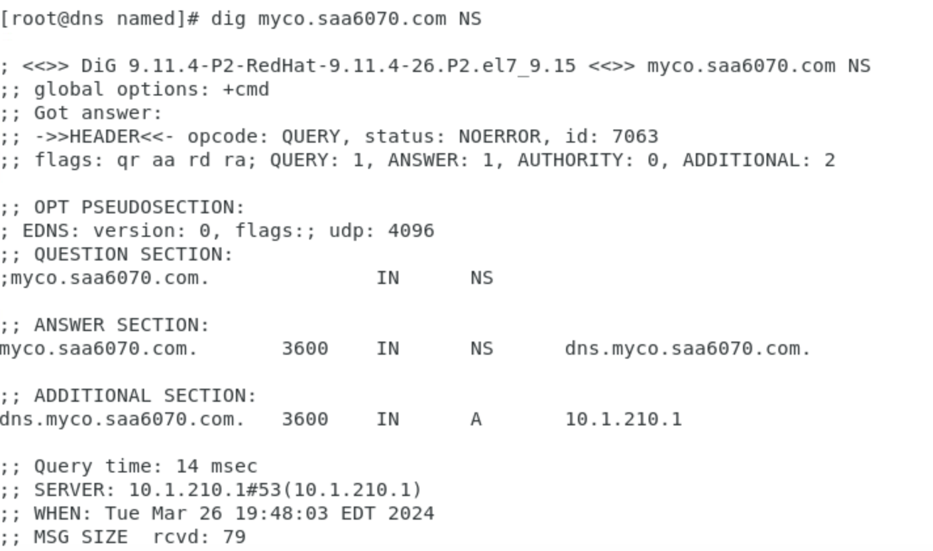

**Reverse DNS lookup (PTR (Pointer)) record query for the IP address**

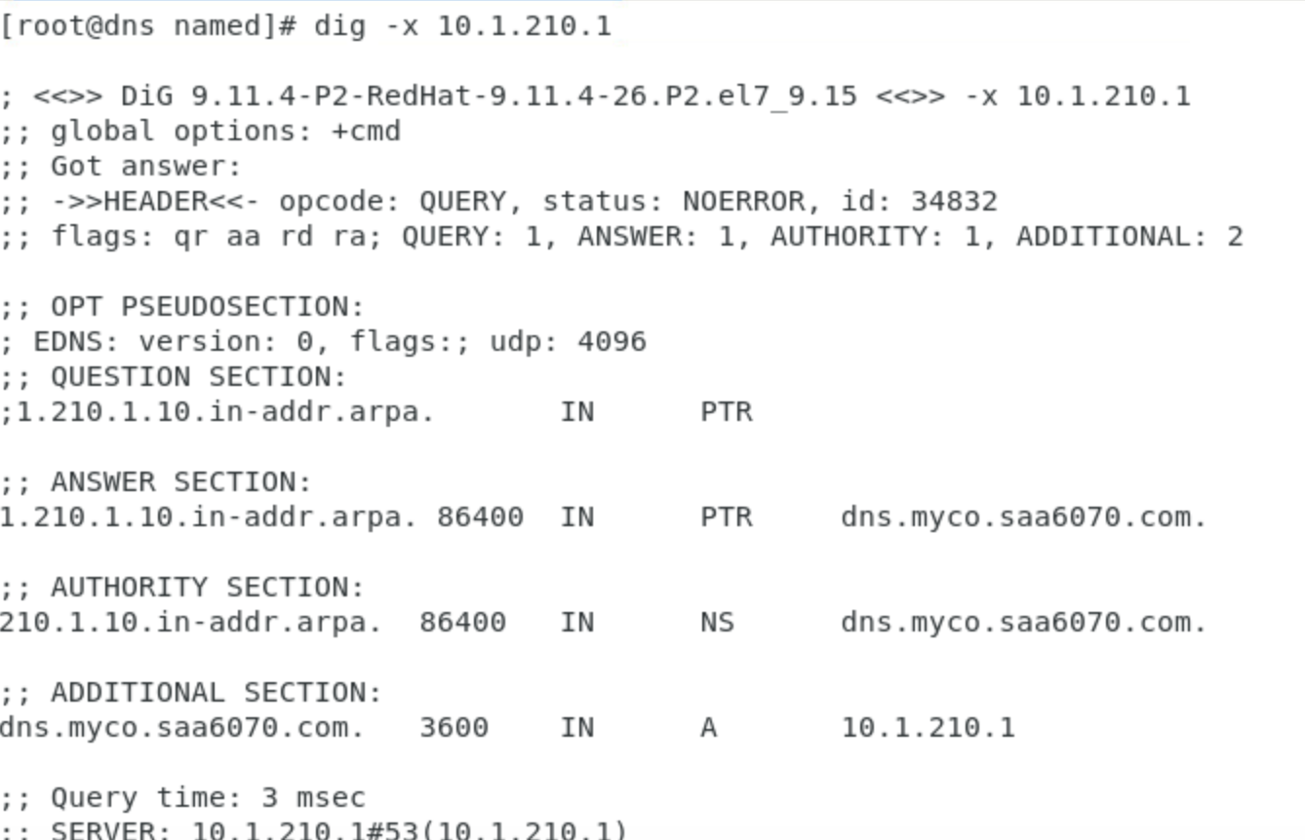

**The command ‘host -t ns’ is used to find out what is the authoritative name server for a domain, while ‘host -C hostname’ gathers as much information as possible about the hostname.**

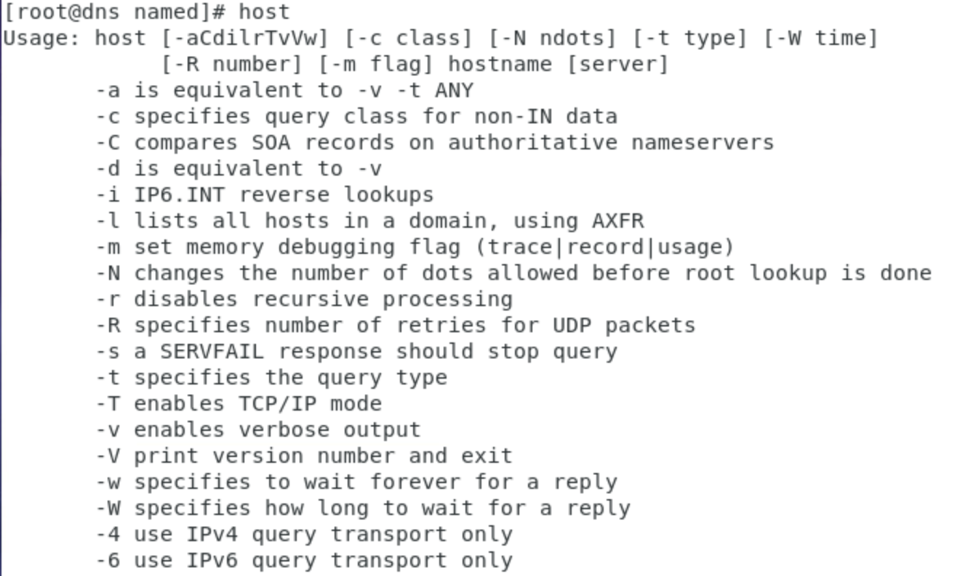

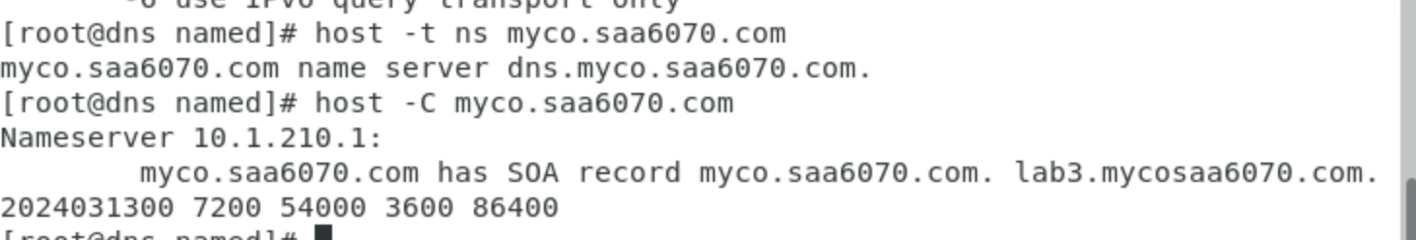

**Changing the domain name of the Win10**

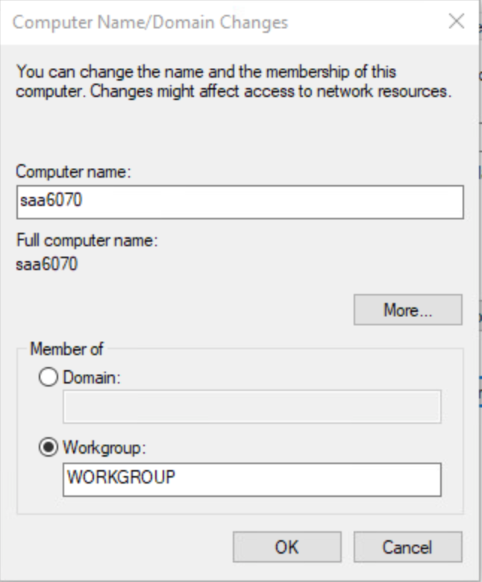

**Changing the domain name of the Windows Server**

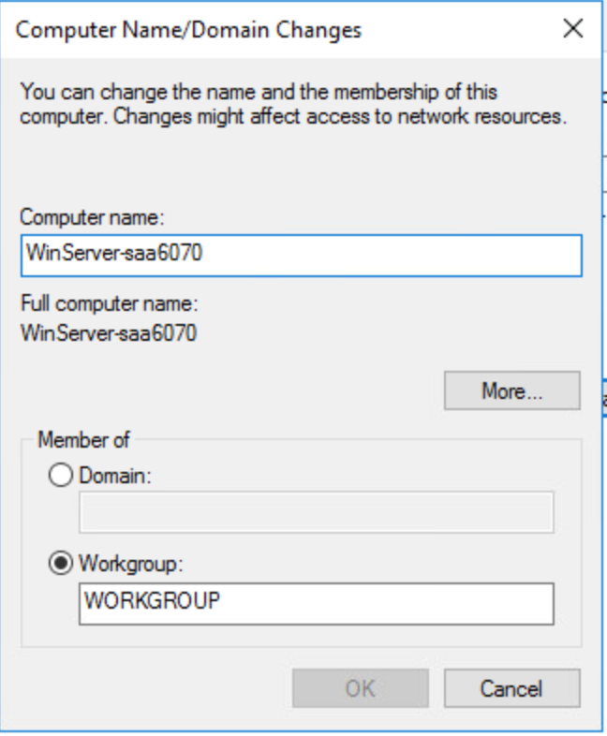

**Pinging Windows server to Windows 10**

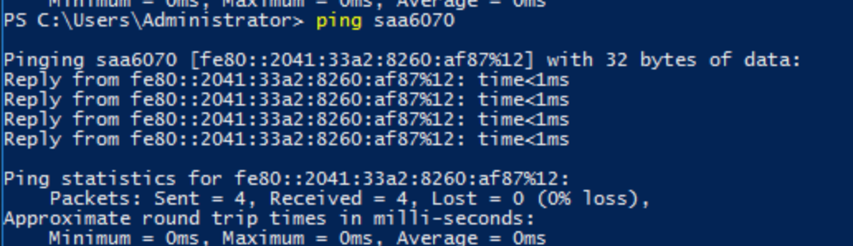

**Pinging Windows server to Centos**

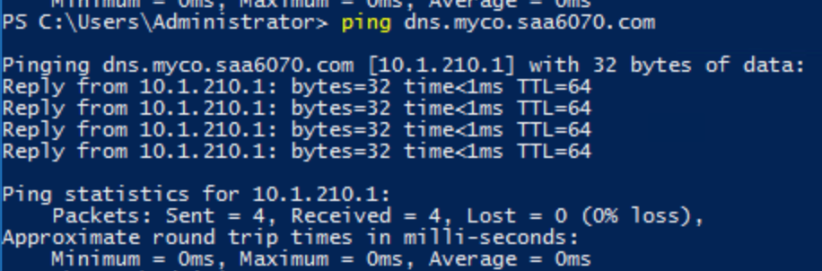

**Pinging Windows 10 to Windows Server**

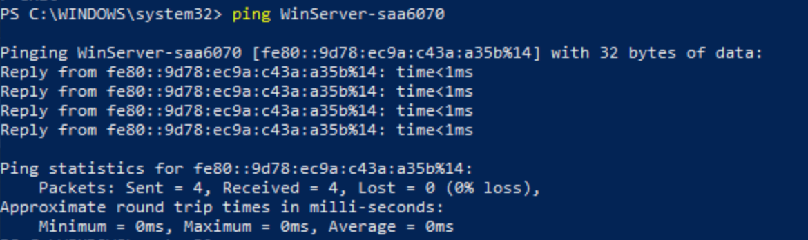

**Pinging Windows 10 to Centos**

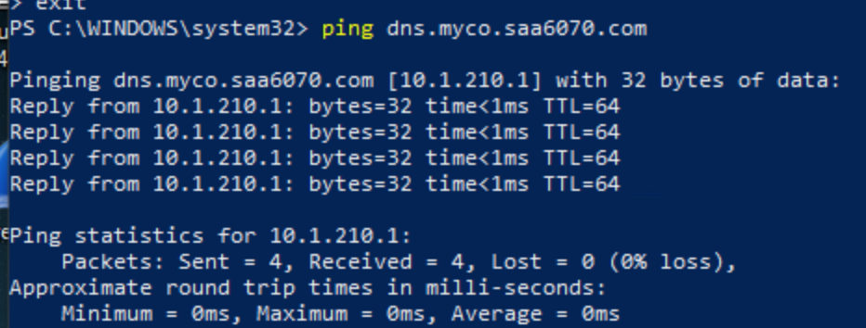

**Pinging Centos to Windows 10**

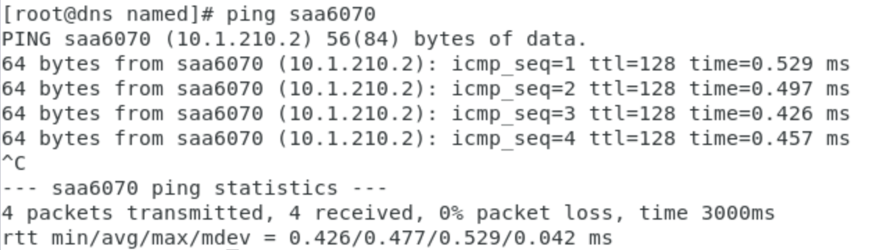

**Pinging Centos to Windows Server**

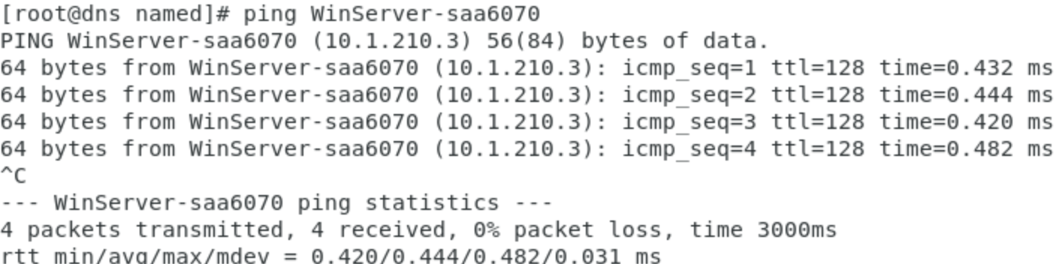

**Using Wireshark to capture the nslookup**